Geology from points and lines

This QGIS plugin incorporates a GIS methodology for generating topologically correct geological maps from vector point data (centroids with geological attributes) and linear data (geological boundaries). The process involves: converting lines into polygons, spatial join with centroids for attribute inheritance, and topological verification to ensure the absence of gaps, overlaps, and duplicates.

Software installation
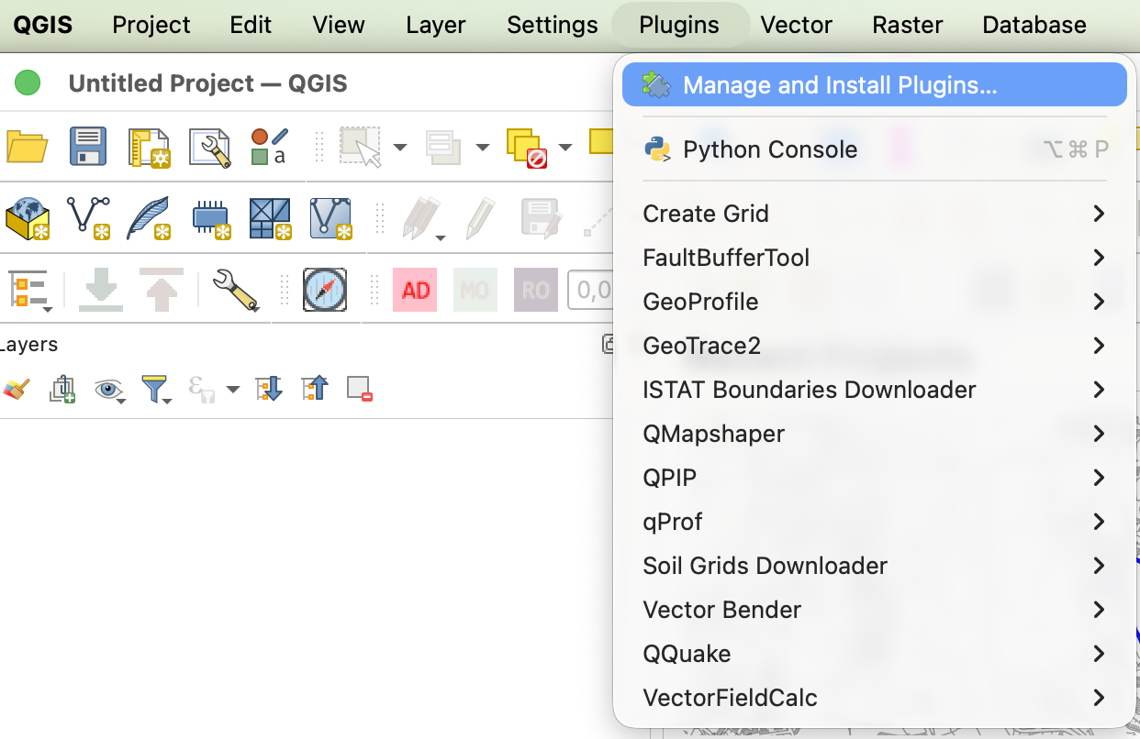
Installation is performed directly from the QGIS plugins section (Figure 1. QGIS Plugins Section) by entering the keyword "Geology" in the search box (Figure 2. Plugin Search and Installation)..
Figure 1. QGIS Plugins Section

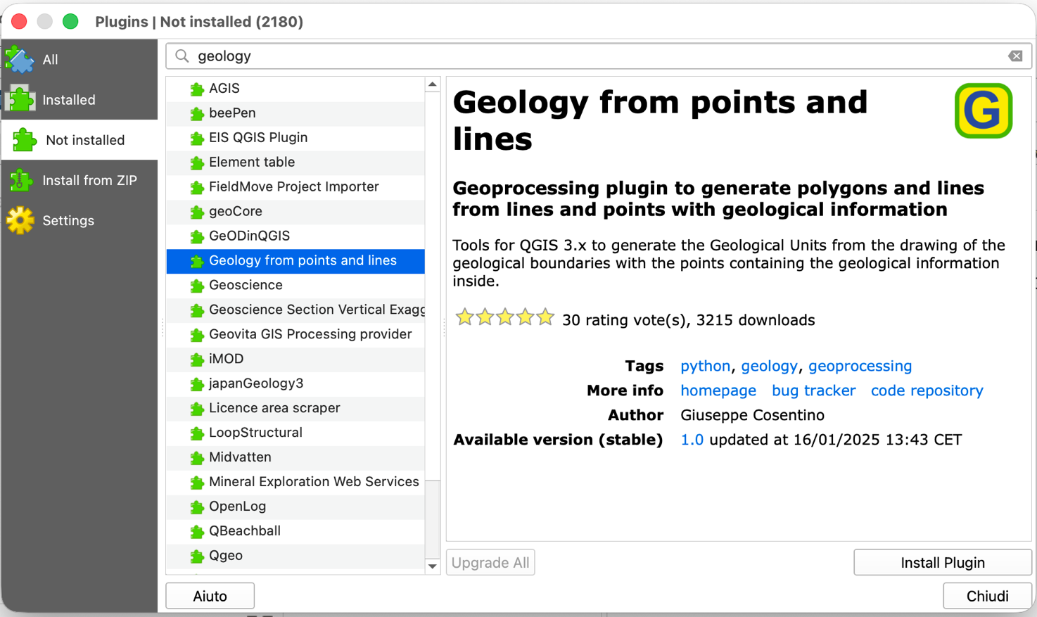
Once installed, the plugin will be available in the Processing Tools section (Figure 3. QGIS Processing Tools Section). Clicking on the tool will open the interface for selecting input files and configuring the geoprocessing operations that will generate the geological map files. (Figure 4. Plugin Input and Output data entry form)
Figure 2. Plugin Search and Installation

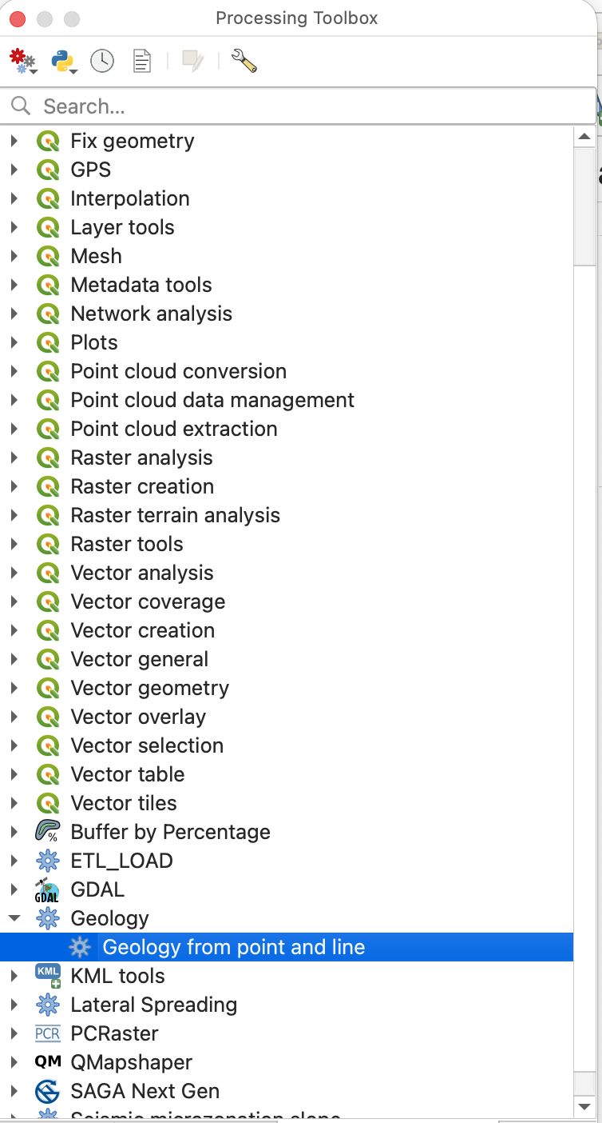
Figure 3. QGIS Processing Tools Section

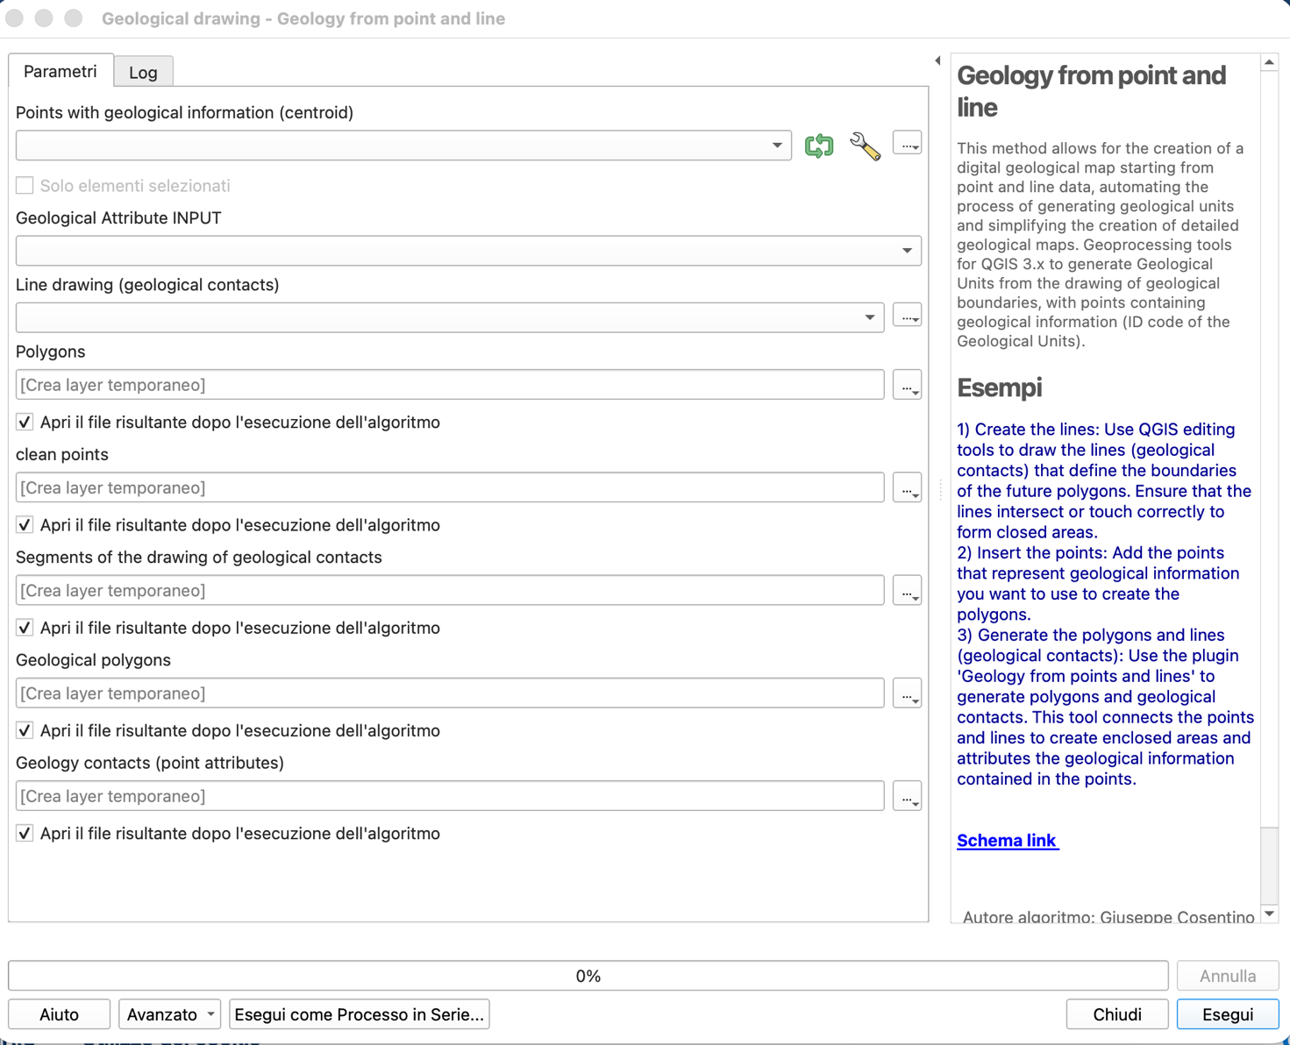
Figure 4. Plugin Input and Output Data Entry Form

Geological Editing Method
1) Create the lines: Use QGIS editing tools to draw the lines (geological contacts) that define the boundaries of the future polygons. Ensure that the lines intersect or touch correctly to form closed areas.
2) Insert the points: Add the points that represent geological information you want to use to create the polygons.
3) Generate the polygons and lines (geological contacts): Use the plugin 'Geology from points and lines' to generate polygons and geological contacts. This tool connects the points and lines to create enclosed areas and attributes the geological information contained in the points.

